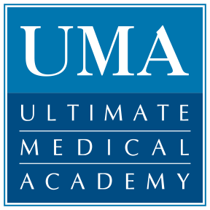
Qualified Medical Candidates Available for Immediate Placement

Have an open position that needs filling? Let UMA be your trusted source for qualified, pre-screened candidates.

UMA’s Career Services Team will work closely with you to provide the right person to fill any level position and streamline the hiring process by saving you:

TIME – Your dedicated UMA Career Services Advisor will find, pre-screen and prepare ambitious medical school graduates for interviewing while you tackle other pressing company needs.

MONEY – While other recruiters charge a fee to provide you with candidates, UMA’s database of qualified graduates is open at NO COST TO YOU.

RESOURCES – Your team can feel confident that the graduates you interview have all completed a rigorous and thorough UMA medical school program and are qualified to immediately become an integral member of your organization.

No matter your need or location, UMA will provide you with the staffing services required to help you stay ahead of the curve during these challenging economic times.

Facility/Practice Name: ______________________________________________________________________
Primary Contact: ____________________________________________________________________________
Phone/Fax/E-mail: __________________________________________________________________________
Position(s) Seeking to Fill: ____________________________________________________________________
Job Description/Special Requests:
□ | Health Unit Coordinator | □ | Medical Collections | □ | Healthcare Information Technology
□ | Medical Insurance Verification | □ | Medical EMR/HER Scanning | □ | Pharmacy Technician
□ | Medical Administrative Assistant | □ | Medical Office Support | □ | Basic X-ray Technician
□ | Medical Assistant | □ | Medical Reception | □ | Medical Clinical Lab Assistant
□ | Medical Billing | □ | Medical/Insurance/Pharmacy Call Center Representative | □ | Dental Assistant
□ | Medical Claims | □ | Patient Coordinator | □ | Healthcare Management
 |  |  |  | □ | Other:____________________

Please complete the following information and fax back to 813-902-7165 or call us at xxx-xxx-xxxx to take advantage of our customized staffing service.

